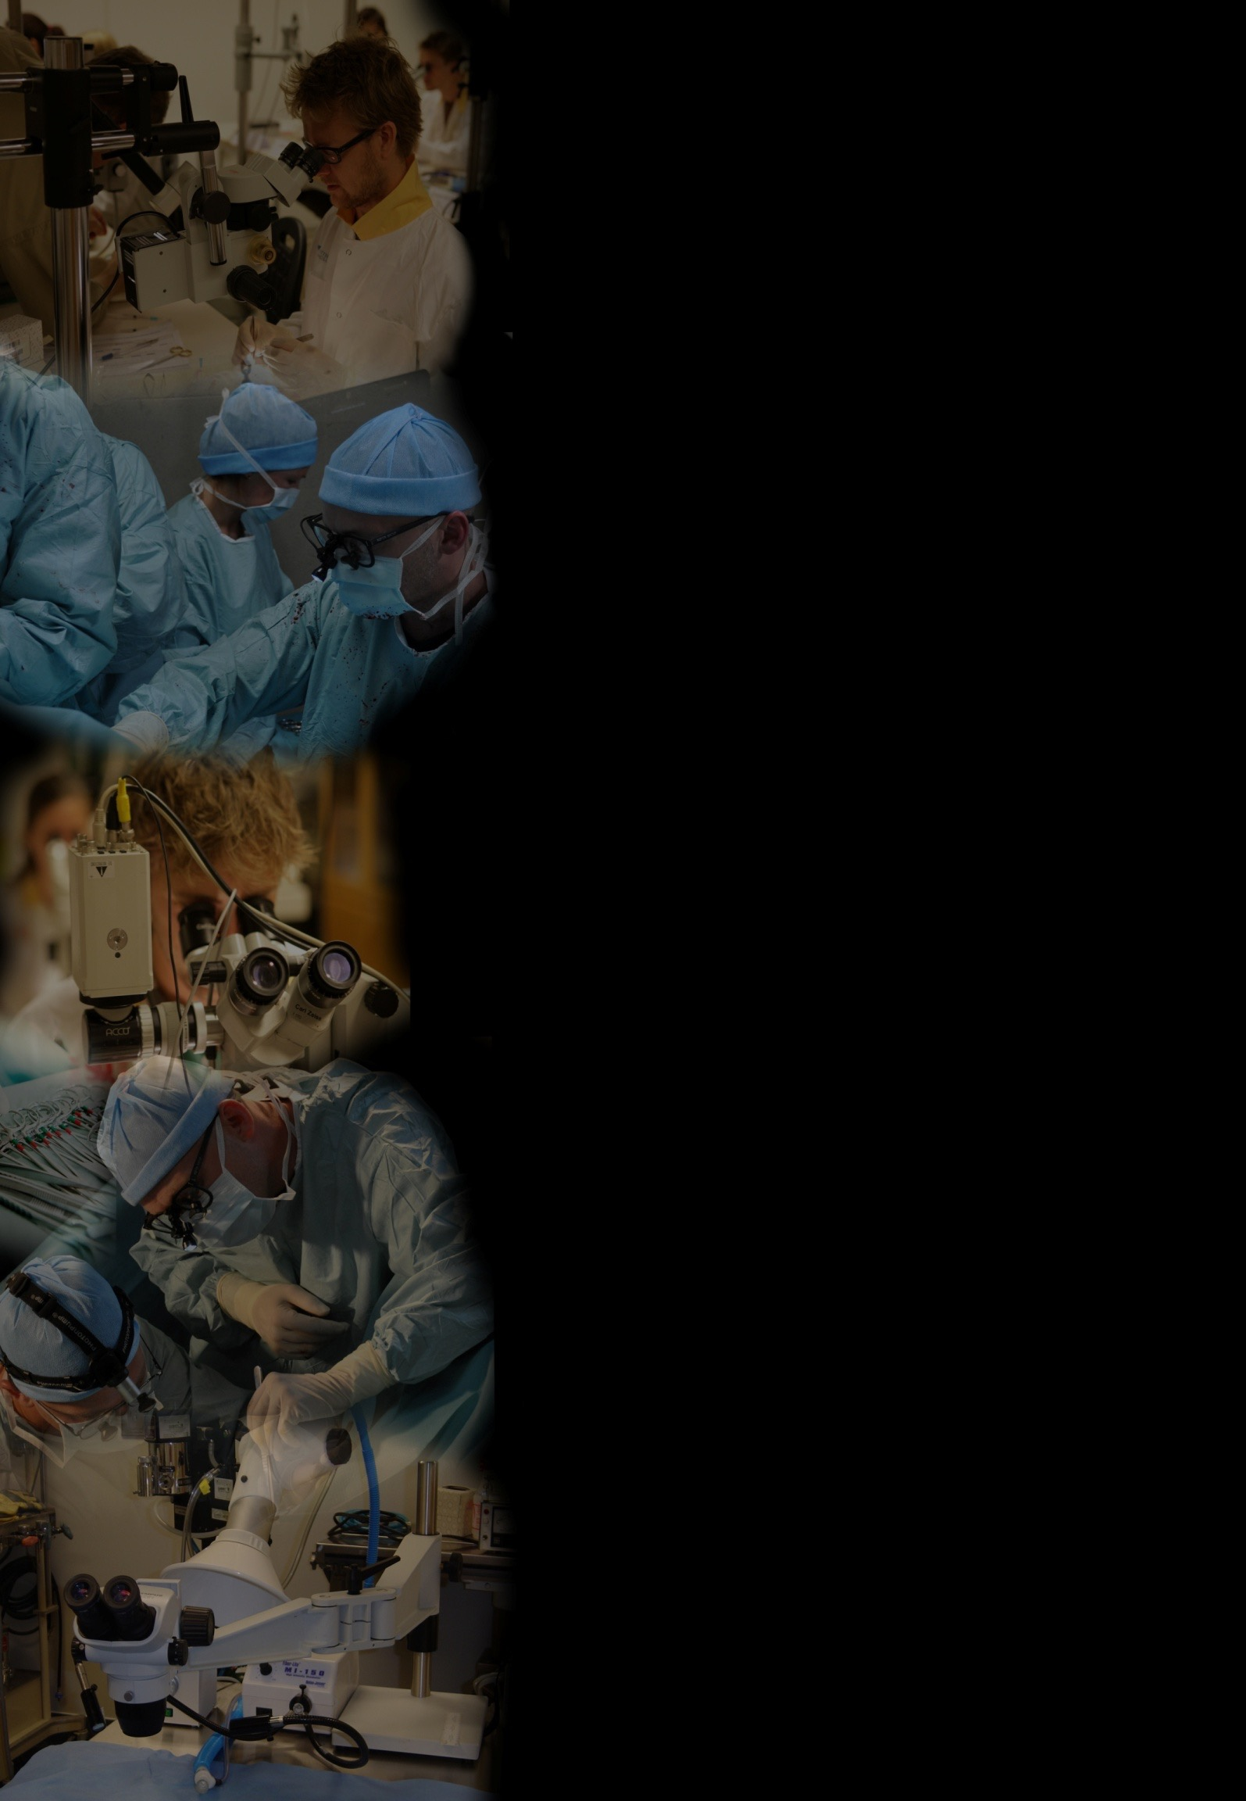
Course content
10th International Course
in Microsurgical Techniques
21 – 25 May, 2018
Gothenburg, Sweden
Theoretical part: information on the operating microscope, ergonomic principles, handling micro-instruments, antithrombotic strategies. Videos on specific exercises are shown and discussed at the beginning of each day
Practical part: the first day participants will train on inanimate models such as latex membranes and chicken thighs or pigs heart. On the remaining days, the training is performed on living tissue (rats). The program can be adapted for individual needs
Monday Approach to the operating microscope; Using micro-instruments; Anti-thrombotic prophylaxis and antispasmotic agents; Basic micro- suture techniques and video demonstration on synthetic material and chicken thighs
Faculty
Paolo Sassu, MD
Andri Thorarinsson, MD
Mattias Liden, MD
Johan Berg, MD
Anders Nilsson, MD
Peter Axelsson, MD
Michael Axelsson
Lars Ewaldsson
Mihai Oltean, MD

Tuesday Surgical approaches in the rat: access to the femoral, carotid, abdominal vessels. Vessels´ exposure and end-to-end anastomosis in the femoral artery
Wednesday End-to-end anastomoses in the femoral vein
Thursday Invited speaker on clinical scenarios; end-to-side anastomosis
More Information at:
WWW.MICROSURGERY.SE
Friday Vein graft; nerve suture on the sciatic or femoral nerve
Surgeons who have attended previous courses are invited to train on free tissue transfer
Course Fees
For application please contact: Kristina Larin
E-mail: kristina.larin@vgregion.se
Telephone: +46-(0)31-3428530
1200 Euros (or 12000 SEK)/person. This includes coffee breaks, lunch, and the course dinner on Thursday.

Location: Gothenburg University,
Scandinavian Microsurgery Academy

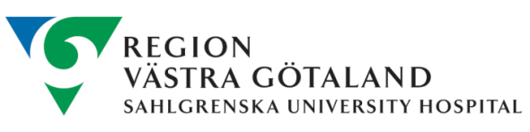
Address:
Medicinaregatan 18A,

Google map: https://goo.gl/maps/5NmMJuyG3KD2

